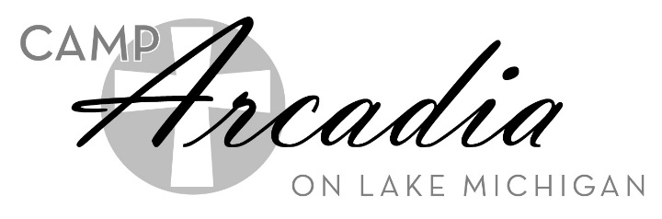

Fall Confirmation Retreats

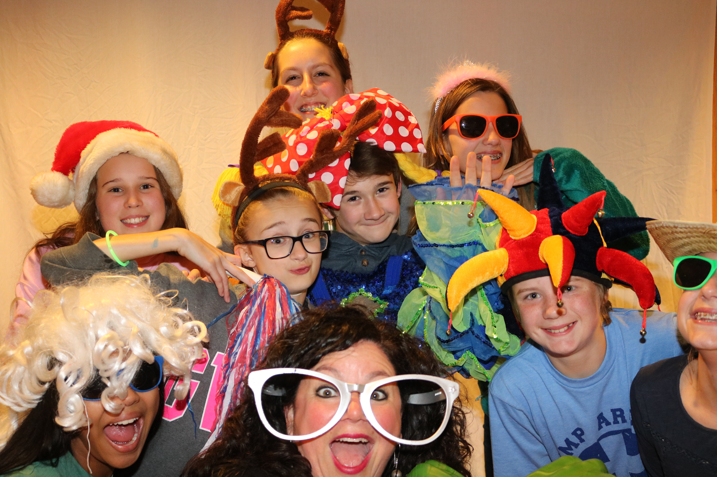
Get excited to eat, play, learn and worship together with your whole confirmation class. Spend time outdoors engaged in activities such as volleyball, basketball, ga-ga ball and group games. Have a blast hanging out with your church friends and meet new friends from other churches. Listen to awesome speakers who will help you understand how to live out your faith in real life!

Who: 7th or 8th grade confirmation students
Three Weekend Retreats to choose from for 2019!

What: A fun-filled weekend spent making friends, growing with God, eating great food, worshiping and having fun at Camp Arcadia
Fall Confirmation Retreat 1 October 4-6, 2019
with Rev. Dave McGinley

Where: Camp Arcadia, Arcadia, MI, on the shore of Lake Michigan
Fall Confirmation Retreat 2 October 11-13, 2019
with Rev. Brian Davies

Cost: $129 per youth (Scholarships are available)
$103 per leader (1 leader for every 7 youth; $115 for additional leaders beyond 7:1 ratio)
Fall Confirmation Retreat 3 October 18-20, 2019
with Rev. Bill Yonker
There is a $50 deposit, per person to reserve a spot for this retreat

Register: Talk with your Church Leader!

If you are the Youth Leader,
Visit camp-arcadia.com/confirmation or call (231) 889-4361

